

American International University-Bangladesh (AIUB)

**Department of Computer Science**

**Faculty of Science &Technology (FST)**

**Spring 19_20**

**CSC 2210 Object Oriented Analysis and Design (OOAD)**

**Section: B**

**AIUB PARKING SPACE MANAGEMENT SYSTEM**

An Object-Oriented Analysis and Design (OOAD) project submitted By

*Tanzina Azmarin Sharna*

**PROBLEM DEFINITION:**

AIUB has a parking space, and there is some certain problem. In this project we are trying to solve these problems. The main problem is, the road from Kuratoli to university is very narrow. If the permanent space of AIUB is filled, and other vehicles enters the university to park, there will be a huge traffic jam. So that it can waste our time.

**The System will reduce the traffic jam and also improve the parking system.**

**Use case description:**

**AIUB PARKING SPACE MANAGEMENT SYSTEM**

In a parking system of AIUB user starts placing a ride or choosing parking slot by **log in** in at the system.

System database checks 3times if the ID is valid or not. To have a ride, user check the availability of car. Driver of battery operated transports update the car availability with the car number and keep cars for charging in parking space if needed. In case of car availability user can select ride otherwise they place request for another car. Then any number of the drivers can accept the request and update the car availability with the possible available time he can be reached. User can select his desired one. User has to make ID available for payment by refilling cash. They can also pay by punching ID or logging in to the machine provided in both parking space of secondary gate and inside AIUB. However, the way is the system checks if provided ID has sufficient balance or not when user selects a ride. When system finds sufficient balance, it deducts money from ID and driver gets verification at the same time. To start the ride driver selects a parking slot if available or can request for one during ride. The user can also park his car in the secondary gate maintaining the same process. Parking space information is updated by the gateman.

**Use Case Diagram:**

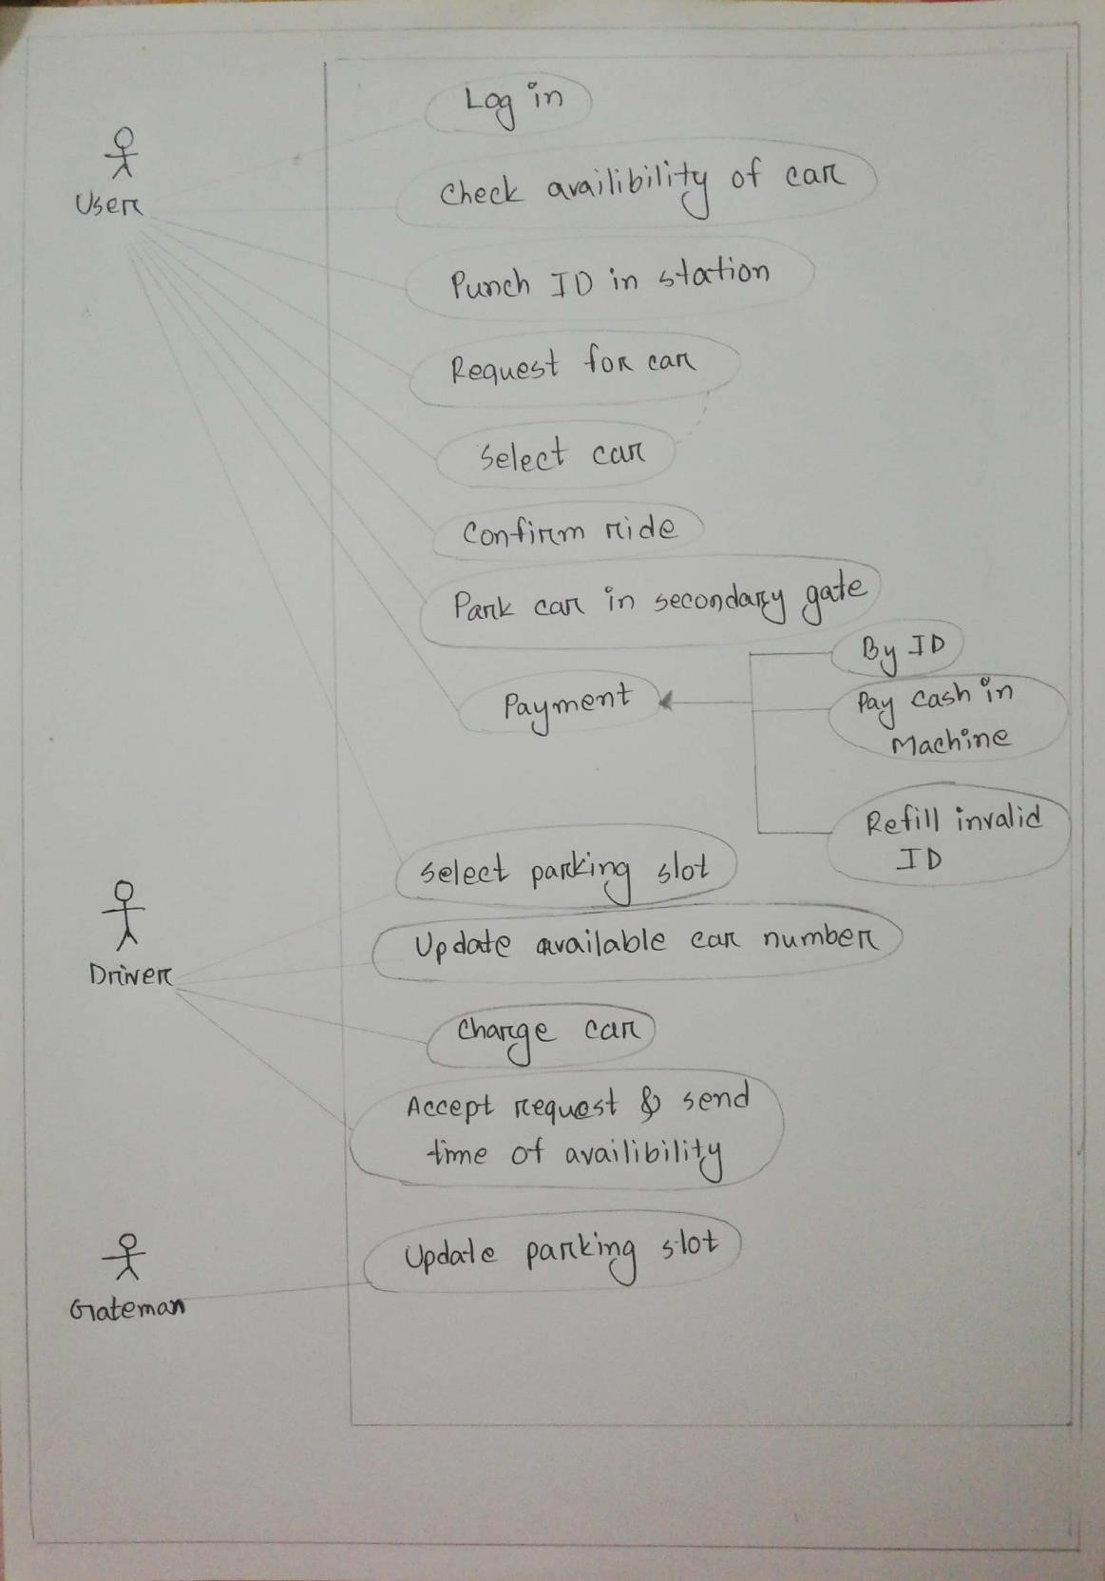

**Activity Diagram:**

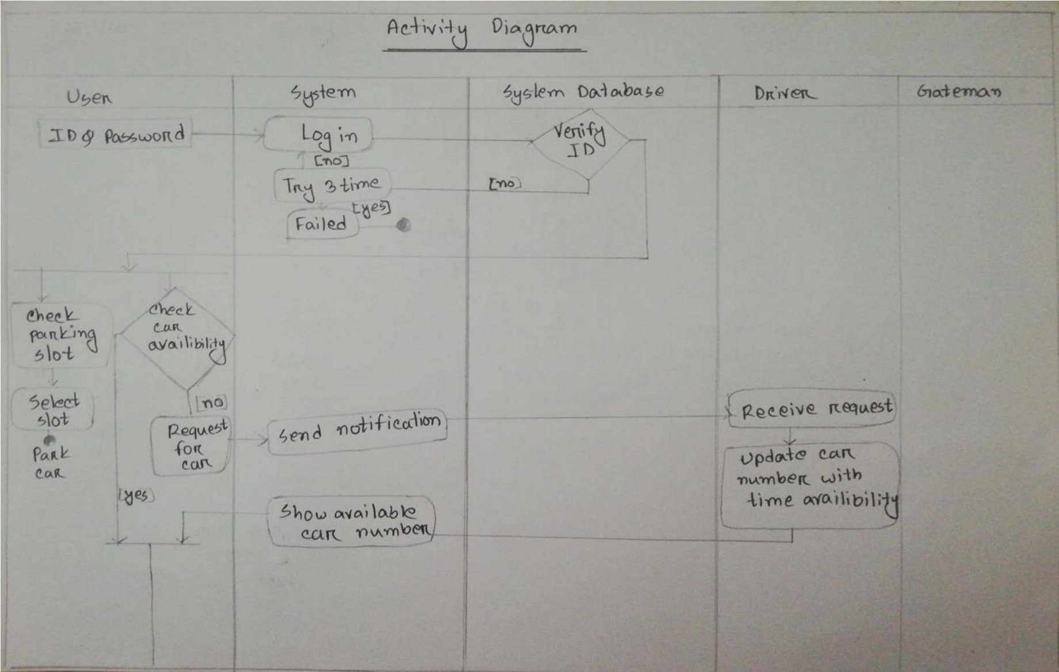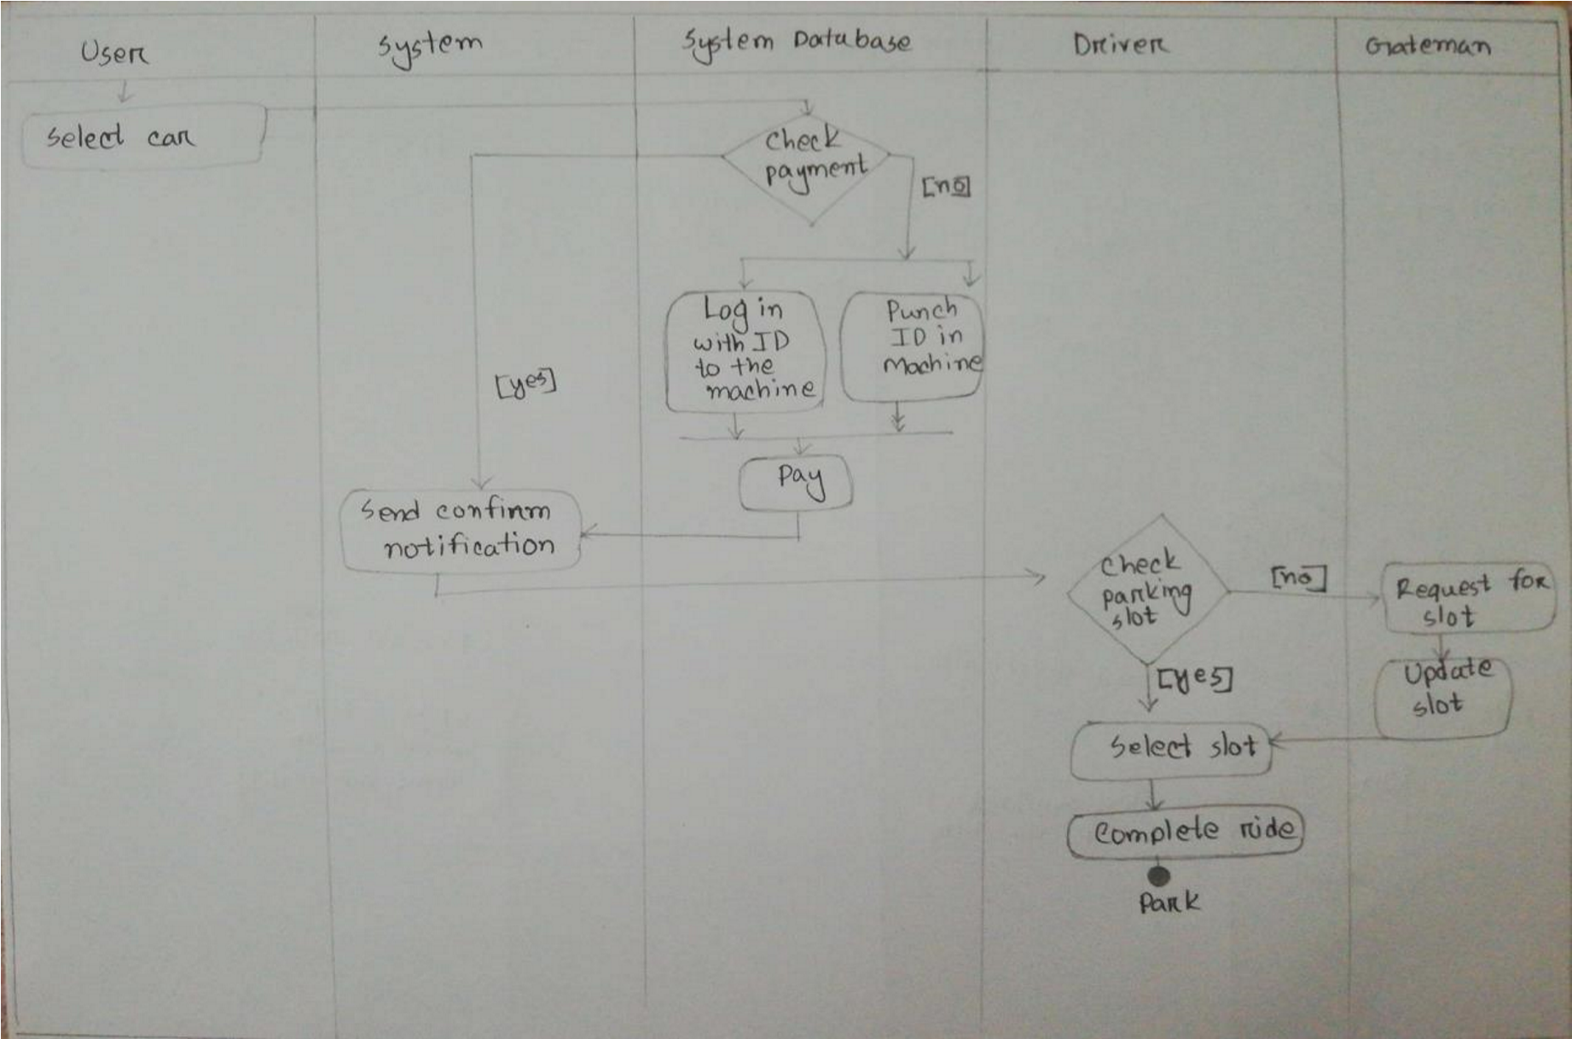

**State Chart Diagram:** 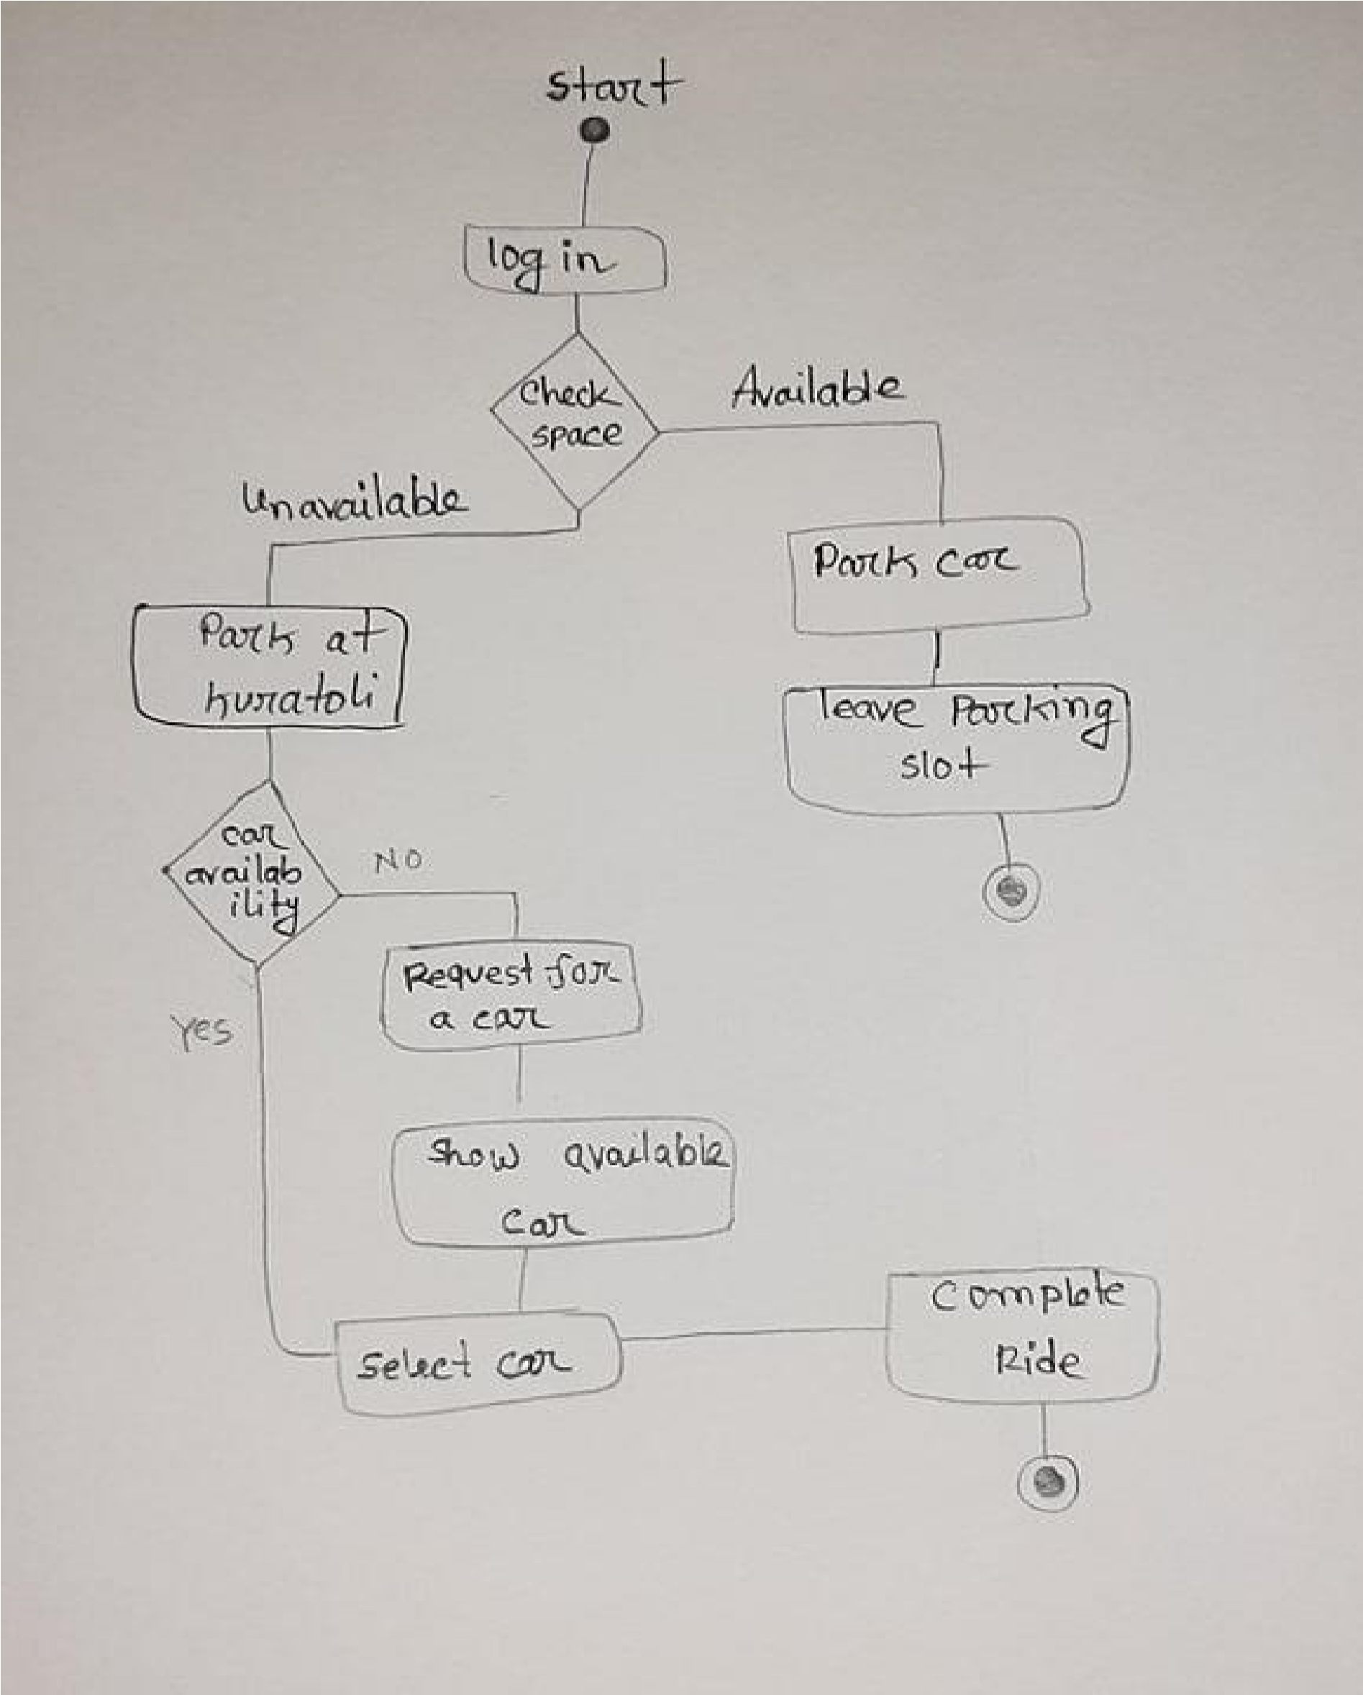

**Sequence diagram:**

